
Professional Portfolio Website
September 11, 2025

Project Overview
This professional portfolio is designed for employers to get a clear and professional view of my skills and experience.

Key Features
- Technical skills
- Projects
- Contact info
- Summary about me

Project Milestones | Description | Start Date | End Date | Status
Planning | Planning what will be included on the website and what colors to use. | September 8th | September 8th | Completed
Design | Start building design on Figma. | September 8th | September 9th | Completed
Development | Starting coding the design in Visual studio Code | September 10th | September 11th | Completed
Testing | Test the website on different size screens. | September 11th | September 11th | Completed

Project Goals
- Display technical skills
- Display professional projects
- Display contact info
- Displays correctly across all screen sizes

Functional Requirements
- Responsive Design- Works correctly on phones, ipads, and desktop.
- Contact Links- Going to the correct destination.

Non-functional Requirements
- Scalability- Easy to add projects.
- Maintainability- Clean structured code.

TimeLine
Monday- Finish planning design and colors, start designing.
Tuesday- Finish up design using Figma.
Wednesday- Start coding design in VSC.
Thursday- Finishing up code in VSC, starting on documentation.
Friday- Finishing up on documentation.

Resources
- Visual Studio Code
- HTML/CSS
- Figma

Website Description
My professional portfolio website serves as a central hub for my professional identity. It displays my technical skills, design ideas, and project-based learning through the clean navigation. The site is structured as a single-page layout, allowing users to scroll smoothly through sections in the following order: title and About Me, contact links, and project showcases.

Design Section
Wireframes/Mockups
Mobile
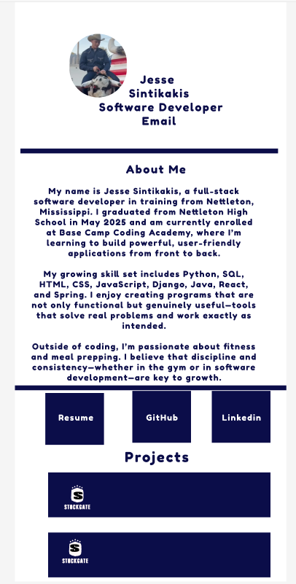

Desktop
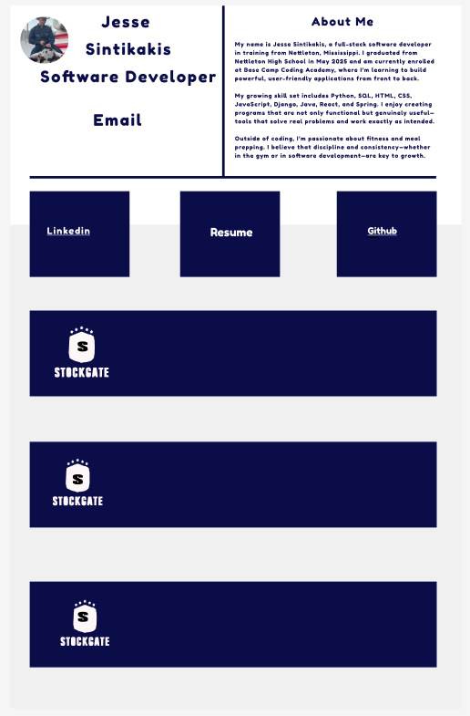

Design Rationale
I chose my color scheme because the deep indigo shows really well on both white and light gray. The white and light gray backgrounds contrast well with the deep indigo, creating a clean and smooth visual experience. I put some information inside of boxes or rectangles that were differently colored to add more detail to it. I used the Font Fredoka One because it is a rounded styling that is not overly thick but can be read easily.

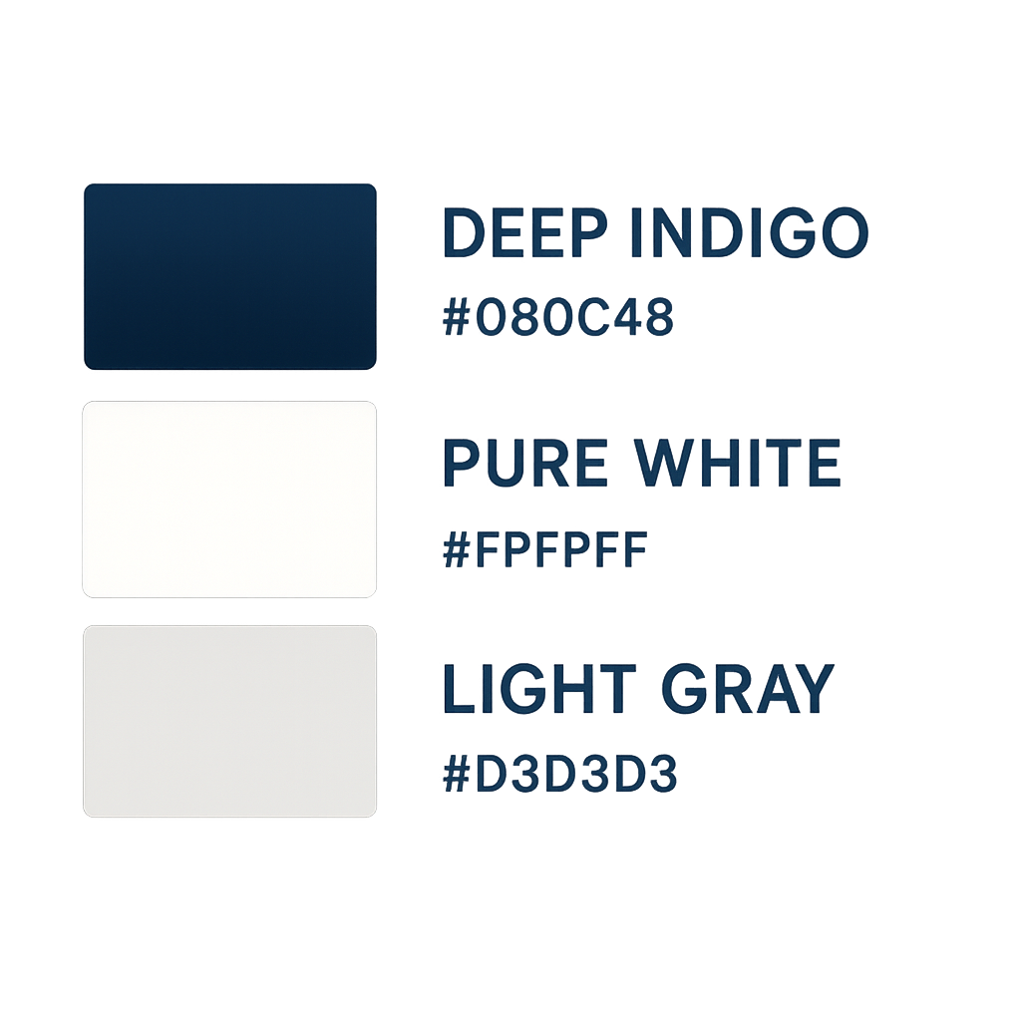

Navigation/User Flow Diagram
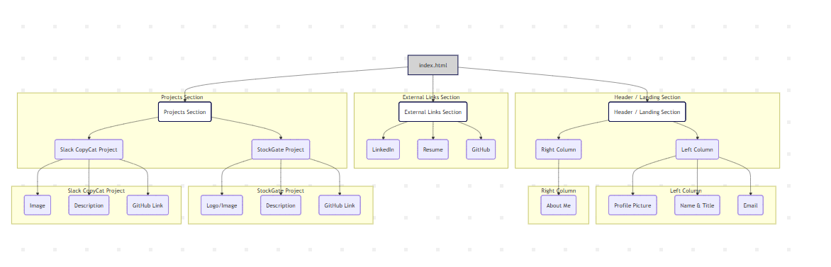

Development Process
I started with the HTML by making two containers on the top, one to hold my about me the other to hold my title and email. Then I made a container below it that has three boxes going across, they contain my contact info and have links to all of my sites. Lastly I made the bottom container which holds my projects and their information.
Github Link: https://github.com/JesseSinti/Professional-Portfolio.git

Screenshots
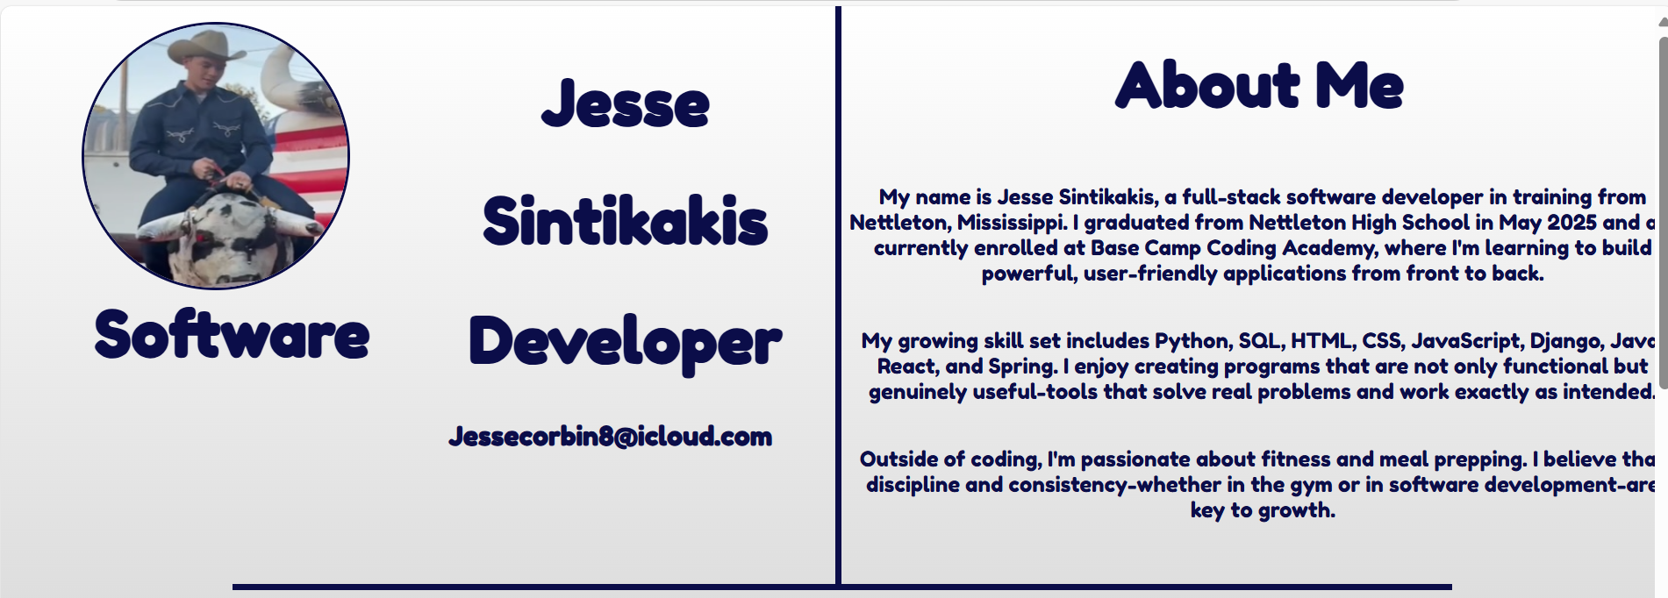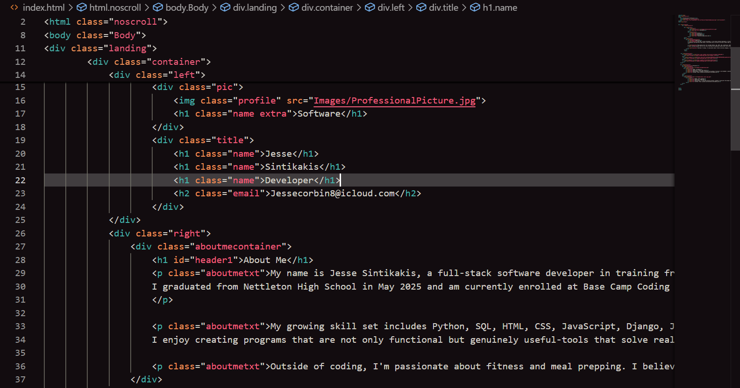
This is how the main page of my site looks and the HTML code for it. The div container Left holds the profile picture, my name, and email. The Right container holds my about me section. This is the CSS that sets those containers up the right way.
They put the Left container to the left side of the screen and the Right container to the right side. It is also what puts the dividing line between the next section.
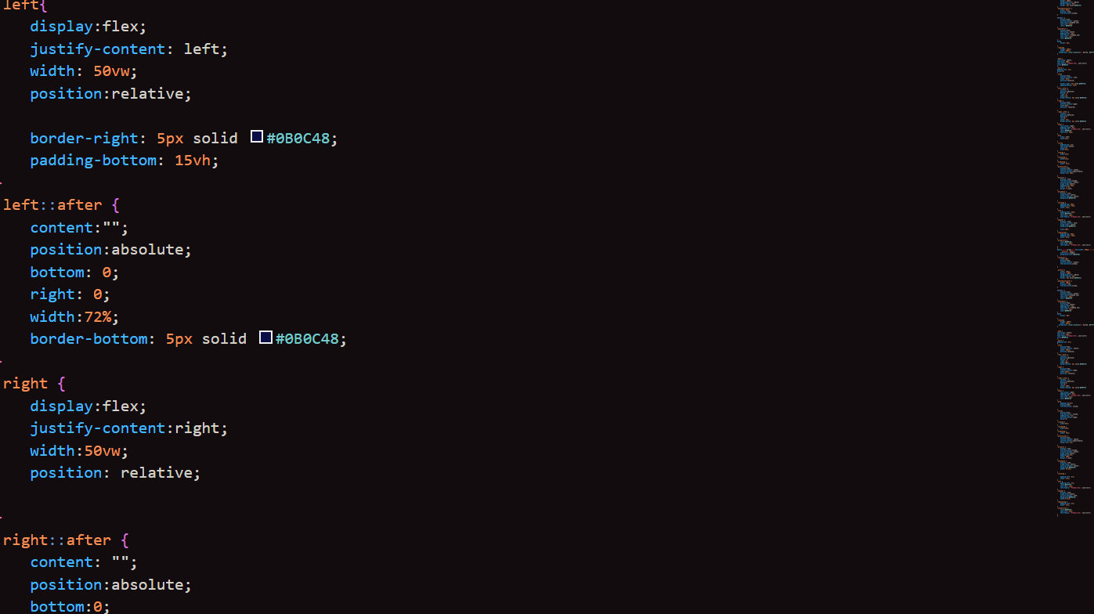
Here is the contact section.

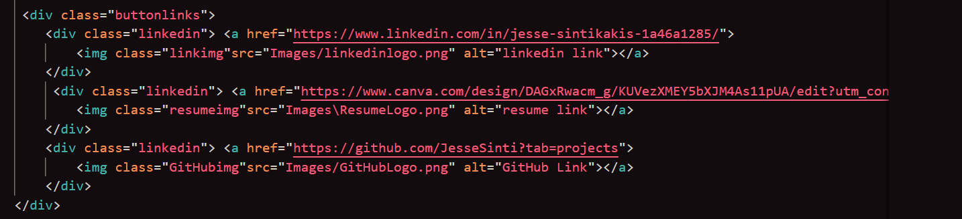
This is the HTML code for the contact section. The buttonlinks div container is what holds this under the top section and it is used to organize the contacts in a row.
Here is the CSS that sets it up in a row and sets the sizing.
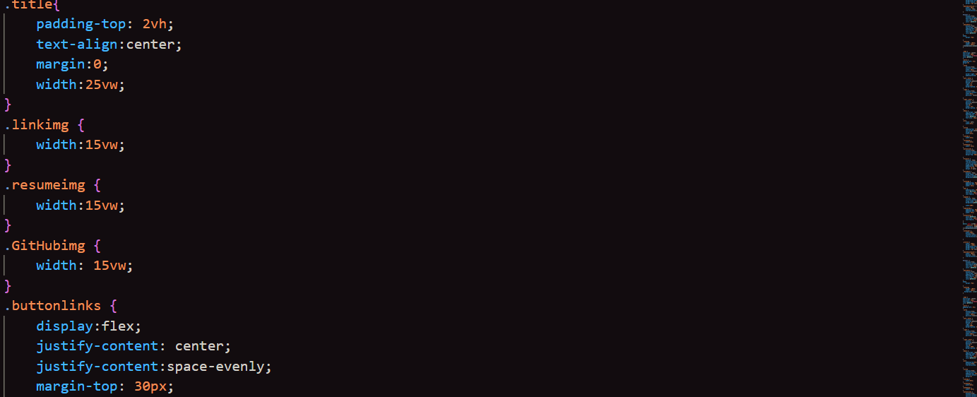
Here is the Projects section that is at the bottom of the website.
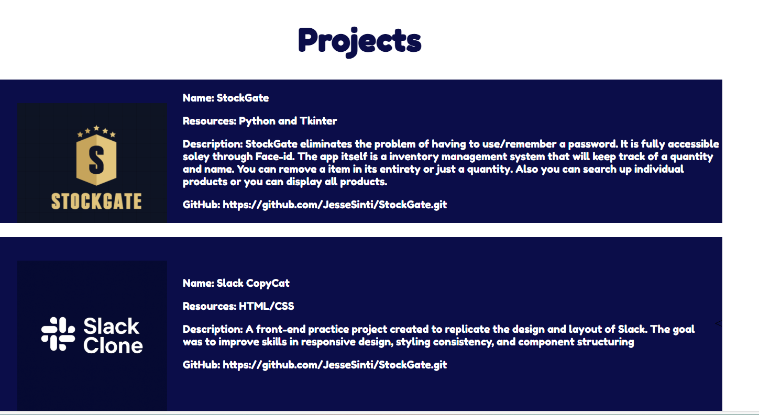
This is the HTML code and its is setting the bottom screen to a container called Projects. Inside this Projects container we are making another container that holds the layout of each project and also sets the sizing.
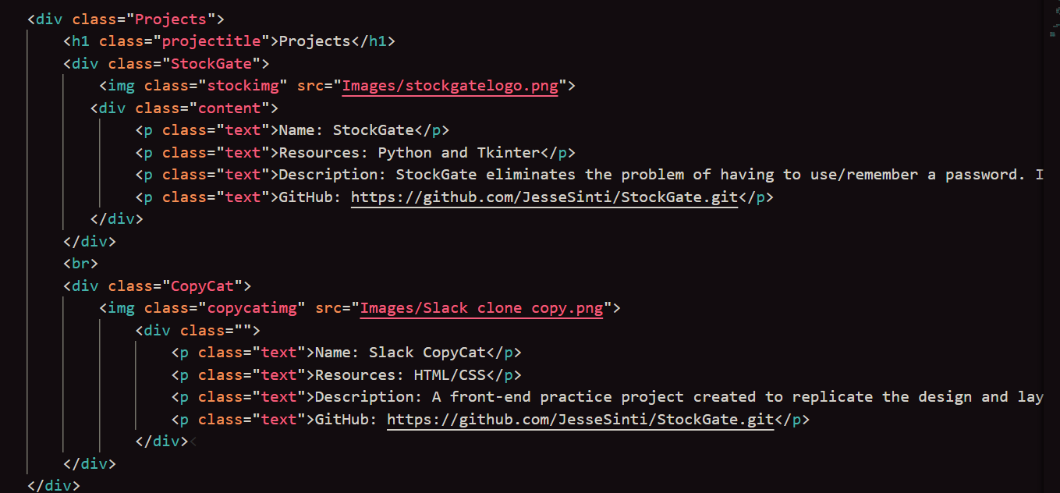
This CSS code is what is organizing the containers inside of Projects and sets the size of project logos/text.
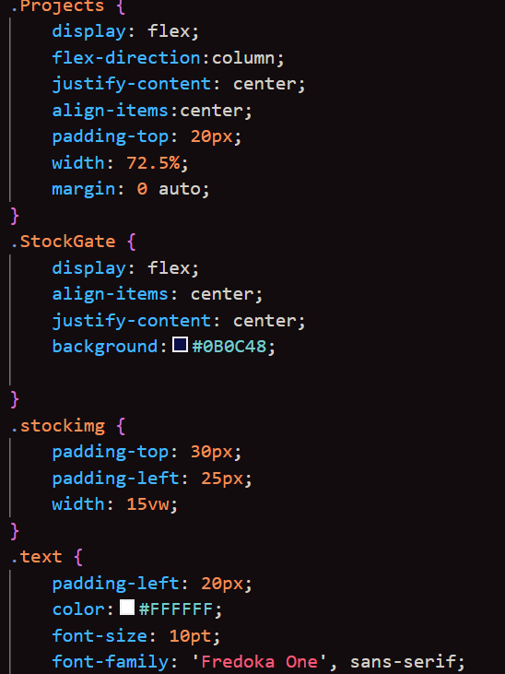
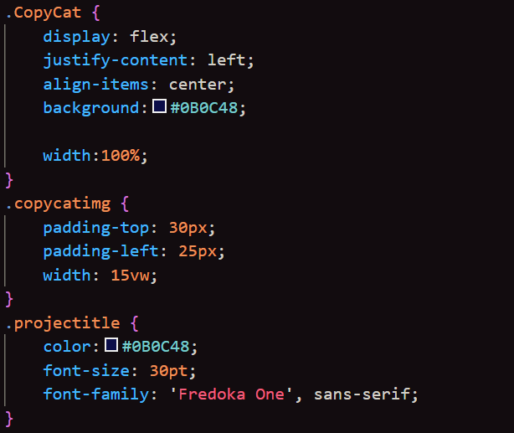

Testing
I manually tested my website among different screen sizes. I had problems getting the images to size correctly along all screens. I was able to fix it by using vw measurements and letting the height auto set.
Phone screen:
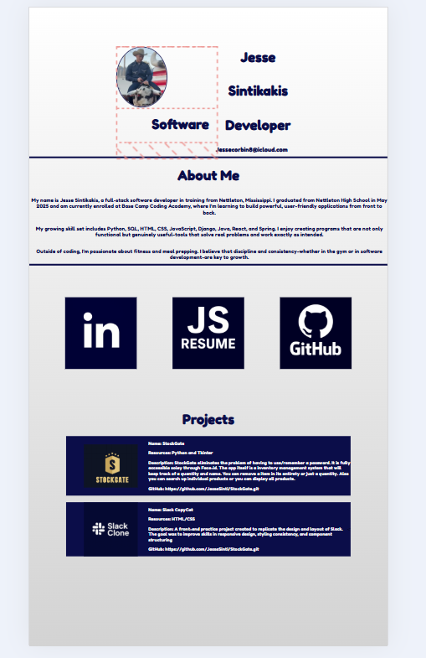

Ipad Screen:
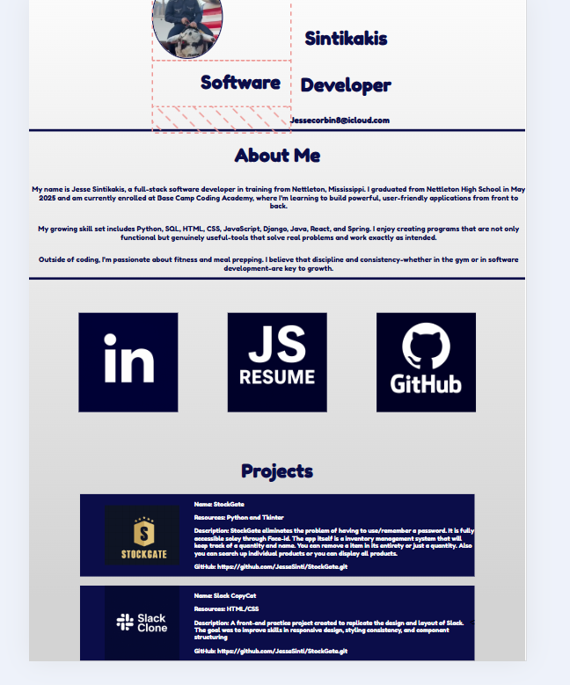

Desktop Screen:
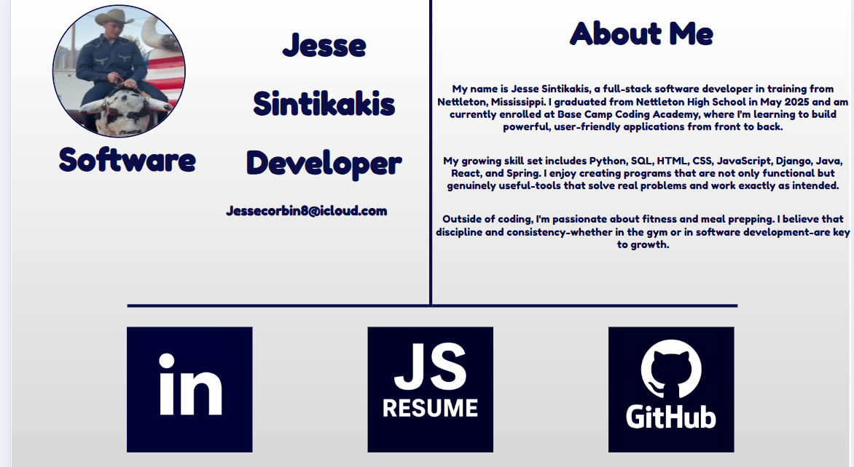
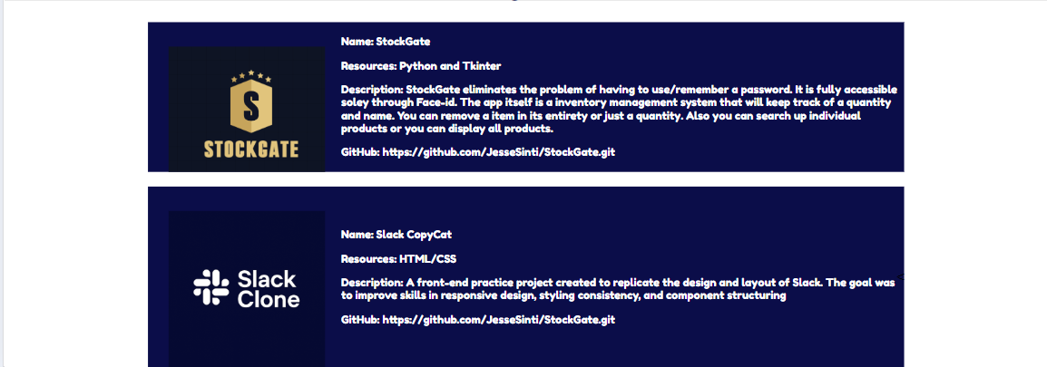

Maintenance Plan
- Monthly bug checks
- Project updates
- New content
Reflection
What I Learned: As I was coding this portfolio I learned a lot about vh and vw measurements. These measurements made scaling a lot easier, and allowed me to make them mobile friendly very quickly.
Challenges I Faced: The only challenge I had was getting my profile picture to stay big enough for mobile, but not being so big it would push my words down the screen.
What Went Well: Fixing up the containers and getting the content aligned worked out really well. It didn’t take long to get it to work and the sizing for it was very easy.
What I Would Do Differently: If I could do it again I would add more details to my website, I would like to make it more interesting and play around with some more color schemes. I believe my site has a lot of room for growth and I definitely plan to improve it over time.

Glossary/Dictionary

Term | Definition
HTML | HyperText Markup Language; the standard language for creating web pages
CSS | Cascading Style Sheets; used to style and layout HTML elements
Responsive Design | A design approach that ensures websites look and function well on all devices
Figma | A web-based design tool used for creating wireframes, mockups, and UI layouts
GitHub | A platform for hosting and sharing code using version control (Git)
Container | A layout element in HTML/CSS used to group and organize content
vw/vh | Viewport width/height units used in CSS for responsive sizing
Modal | A pop-up window that appears on top of the main page content
Wireframe | A basic visual guide that represents the layout of a web page
Accessability | Designing websites so they can be used by people with disabilities
Scalability | The ability of a website to grow and handle more content or users over time
Maintainability | How easily a website’s code can be updated or improved

